Lab-2 Report
Implementation of CMOS logic gates

MIRIYALA PRANAY KAMAL
200030033

Aim: Identification of logic gates required for the given problems and implementation of the problem using the CMOS logic gates.

Components used:

- IC HCF 4007 CMOS gates
- Resistor array
- DIP switches
- LED displays
- Breadboard
- Power supply
- Mulitmeter

Design Procedure:

Problem Statements:
1. A bulb in a staircase has two switches, one switch being at the ground floor and the other one at the first floor. The bulb can be turned ON and also can be turned OFF only if both the switches are at different states. Design the CMOS circuit for this logic.

Solution: XOR Gate.

2. A commercial building a powered by two renewable sources of energy – solar and wind. There are two alarms associated to both the generation stations that get HIGH if the power generation in any day is below the threshold values. Design the CMOS circuit that implements the logic of a third alarm which is switched ON if the generation by both the sources are below threshold on any given day.

Solution: AND Gate.

These XOR and AND gates can be implemented by using CMOS IC HCF 4007. The logic tables/Truth tables for these gates are:

AND GATE
INPUT 1 | INPUT 2 | OUTPUT
0 | 0 | 0
0 | 1 | 0
1 | 0 | 0
1 | 1 | 1

XOR GATE
INPUT 1 | INPUT 2 | OUTPUT
0 | 0 | 0
0 | 1 | 1
1 | 0 | 1
1 | 1 | 0

Other gates with CMOS:

NOR GATE

INPUT 1 | INPUT 2 | OUTPUT
0 | 0 | 1
0 | 1 | 0
1 | 0 | 0
1 | 1 | 0

NAND GATE

INPUT 1 | INPUT 2 | OUTPUT
0 | 0 | 1
0 | 1 | 1
1 | 0 | 1
1 | 1 | 0
XNOR GATE

INPUT 1 | INPUT 2 | OUTPUT
0 | 0 | 1
0 | 1 | 0
1 | 0 | 0
1 | 1 | 1

OR GATE

INPUT 1 | INPUT 2 | OUTPUT
0 | 0 | 0
0 | 1 | 1
1 | 0 | 1
1 | 1 | 1

Circuit diagram:

AND GATE USING CMOS

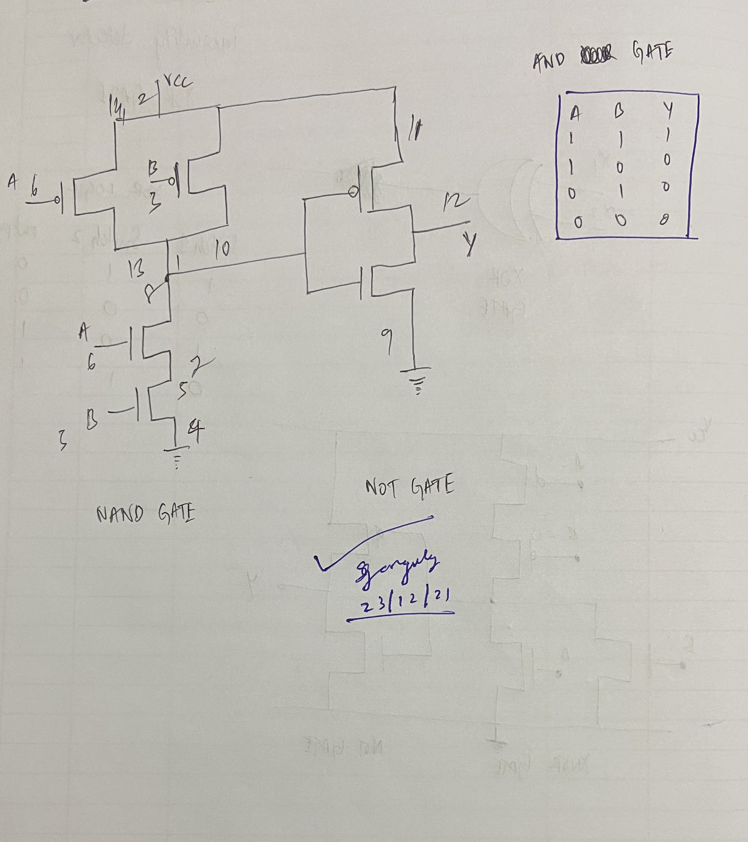

XOR GATE USING CMOS

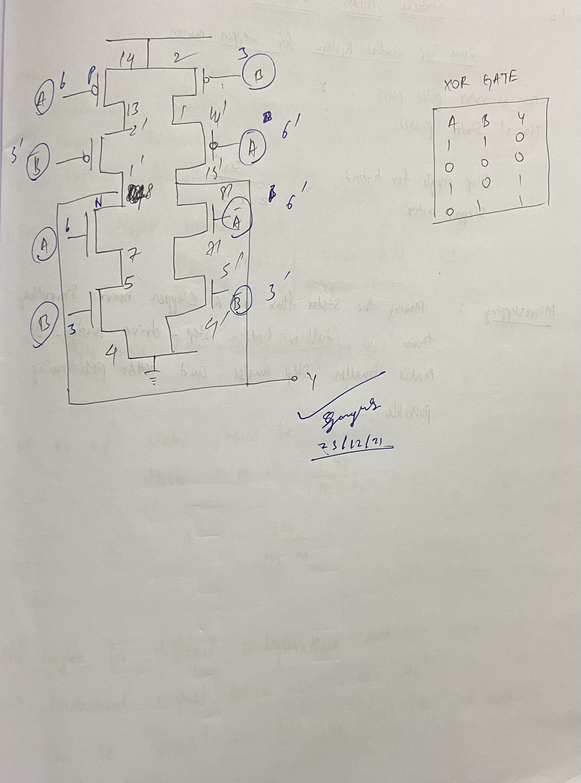

NOR GATE USING CMOS

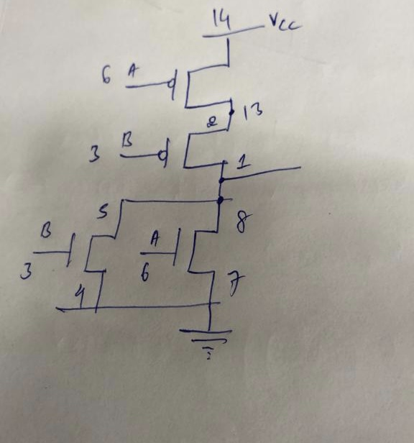

NAND GATE USING CMOS

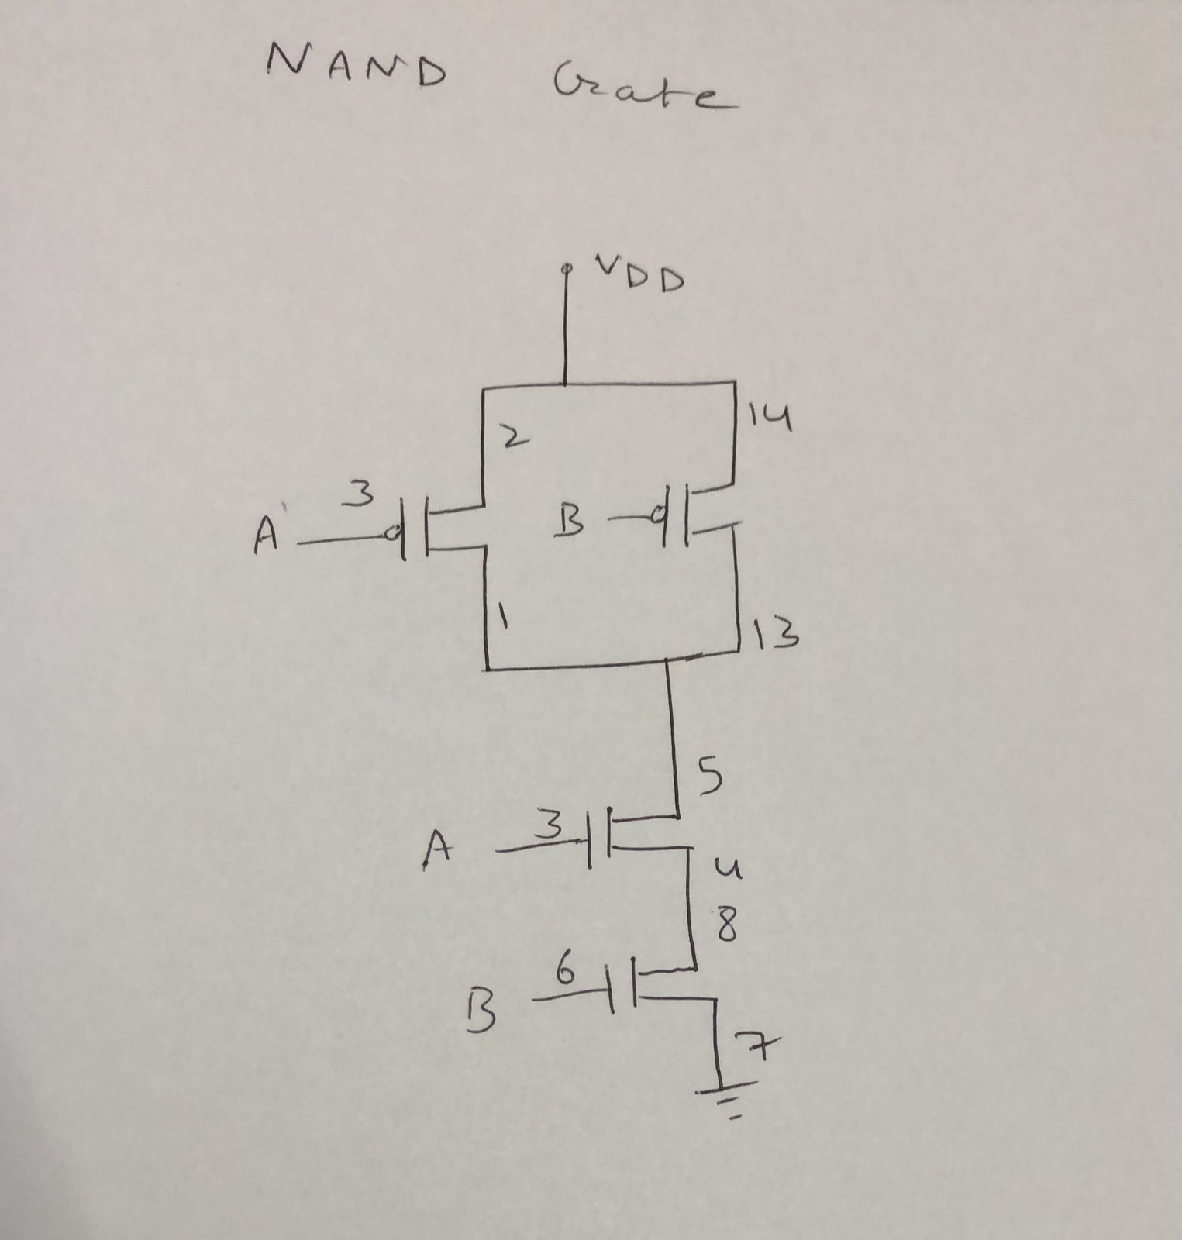

XNOR GATE USING CMOS

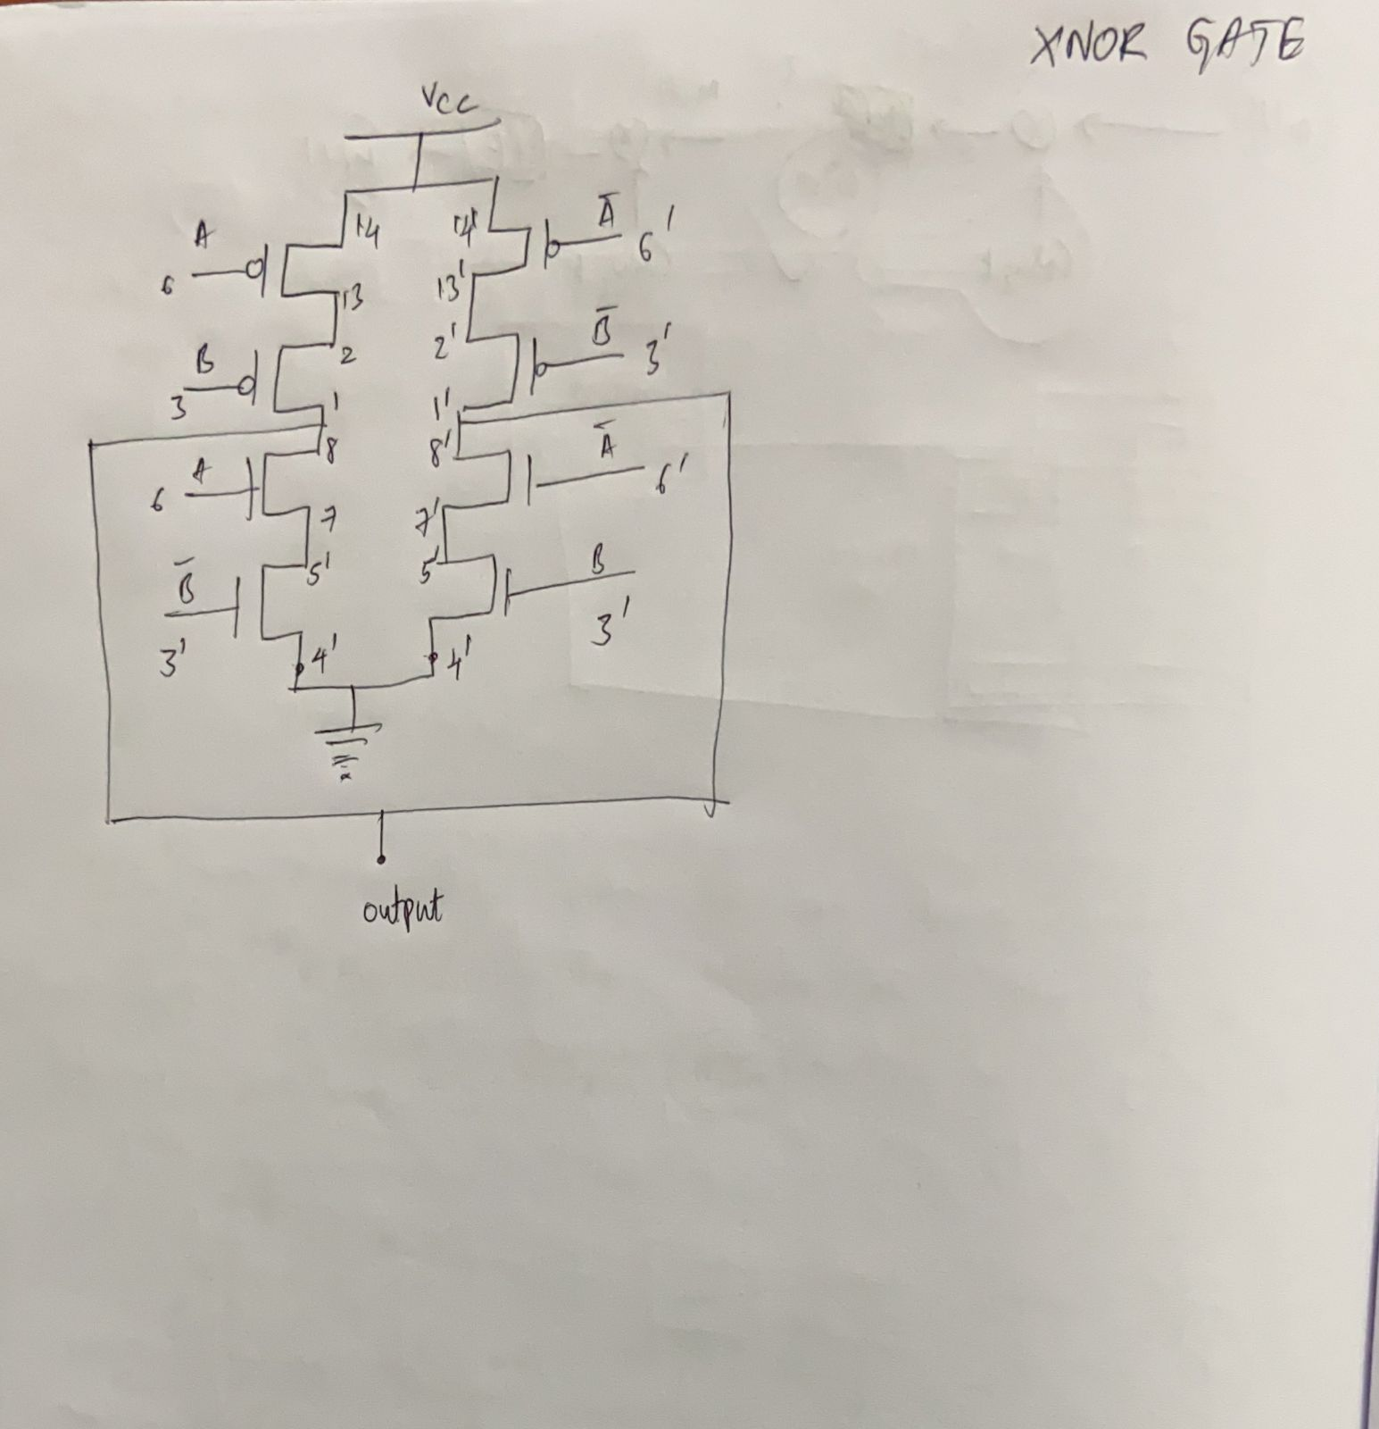

OR GATE USING CMOS

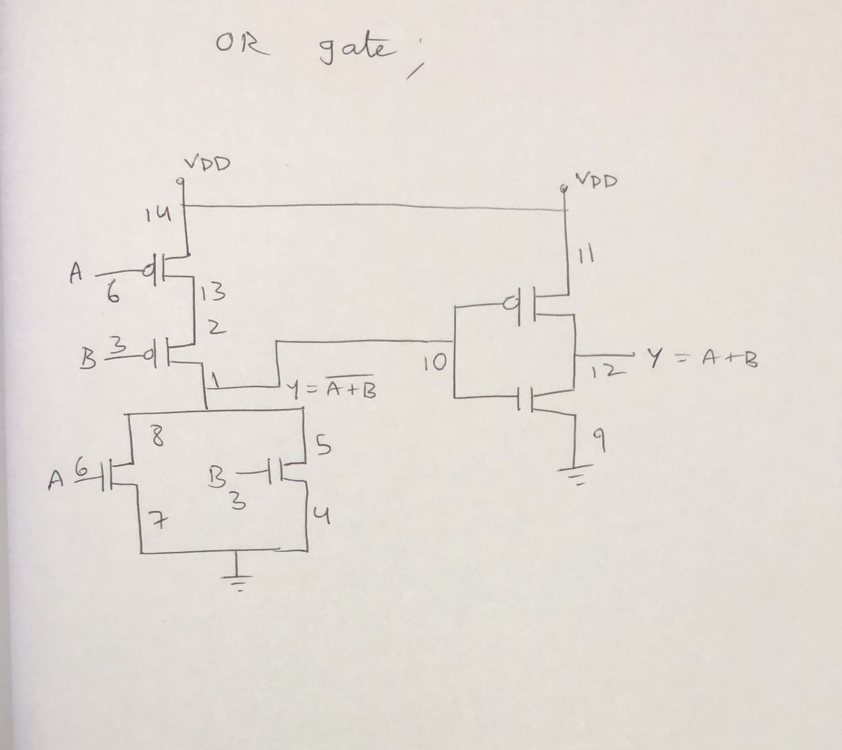

Circuit Snapshots:

- XOR GATE
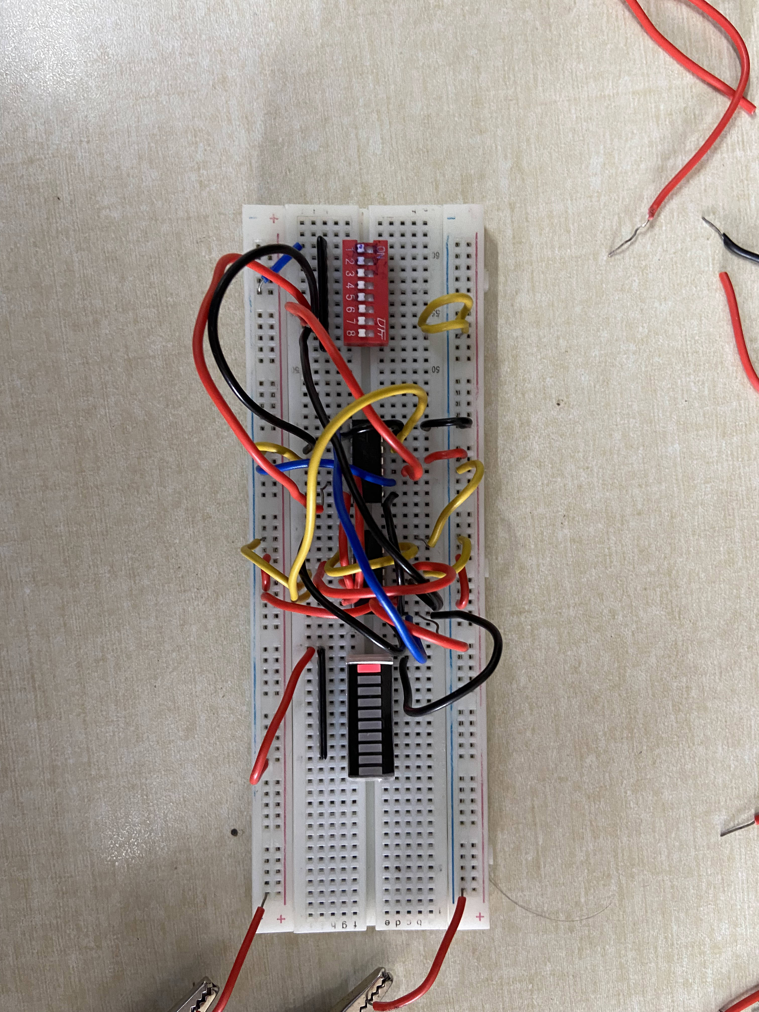
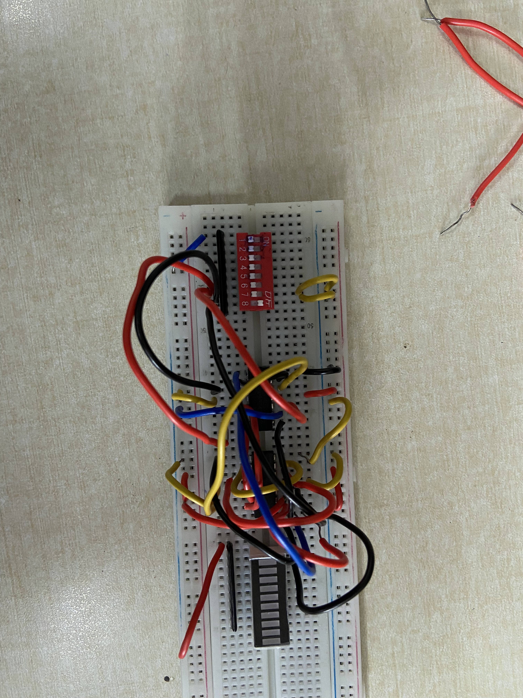

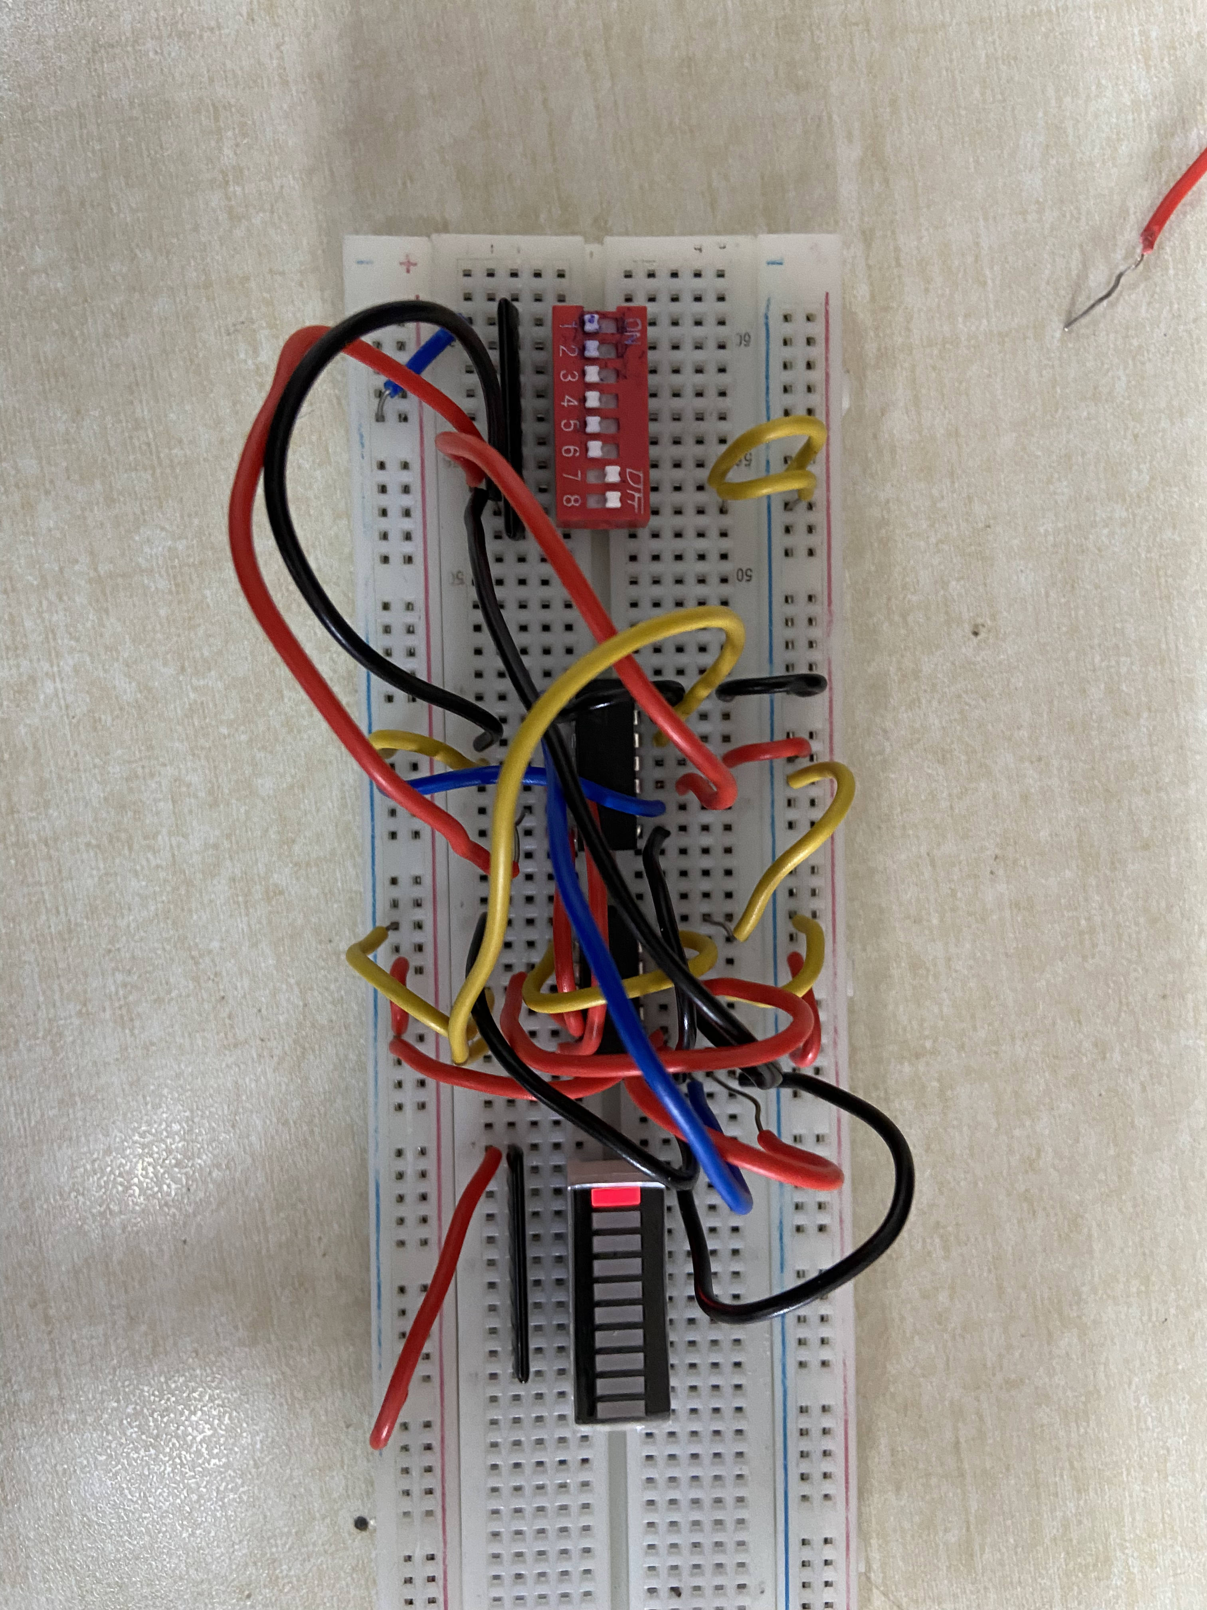
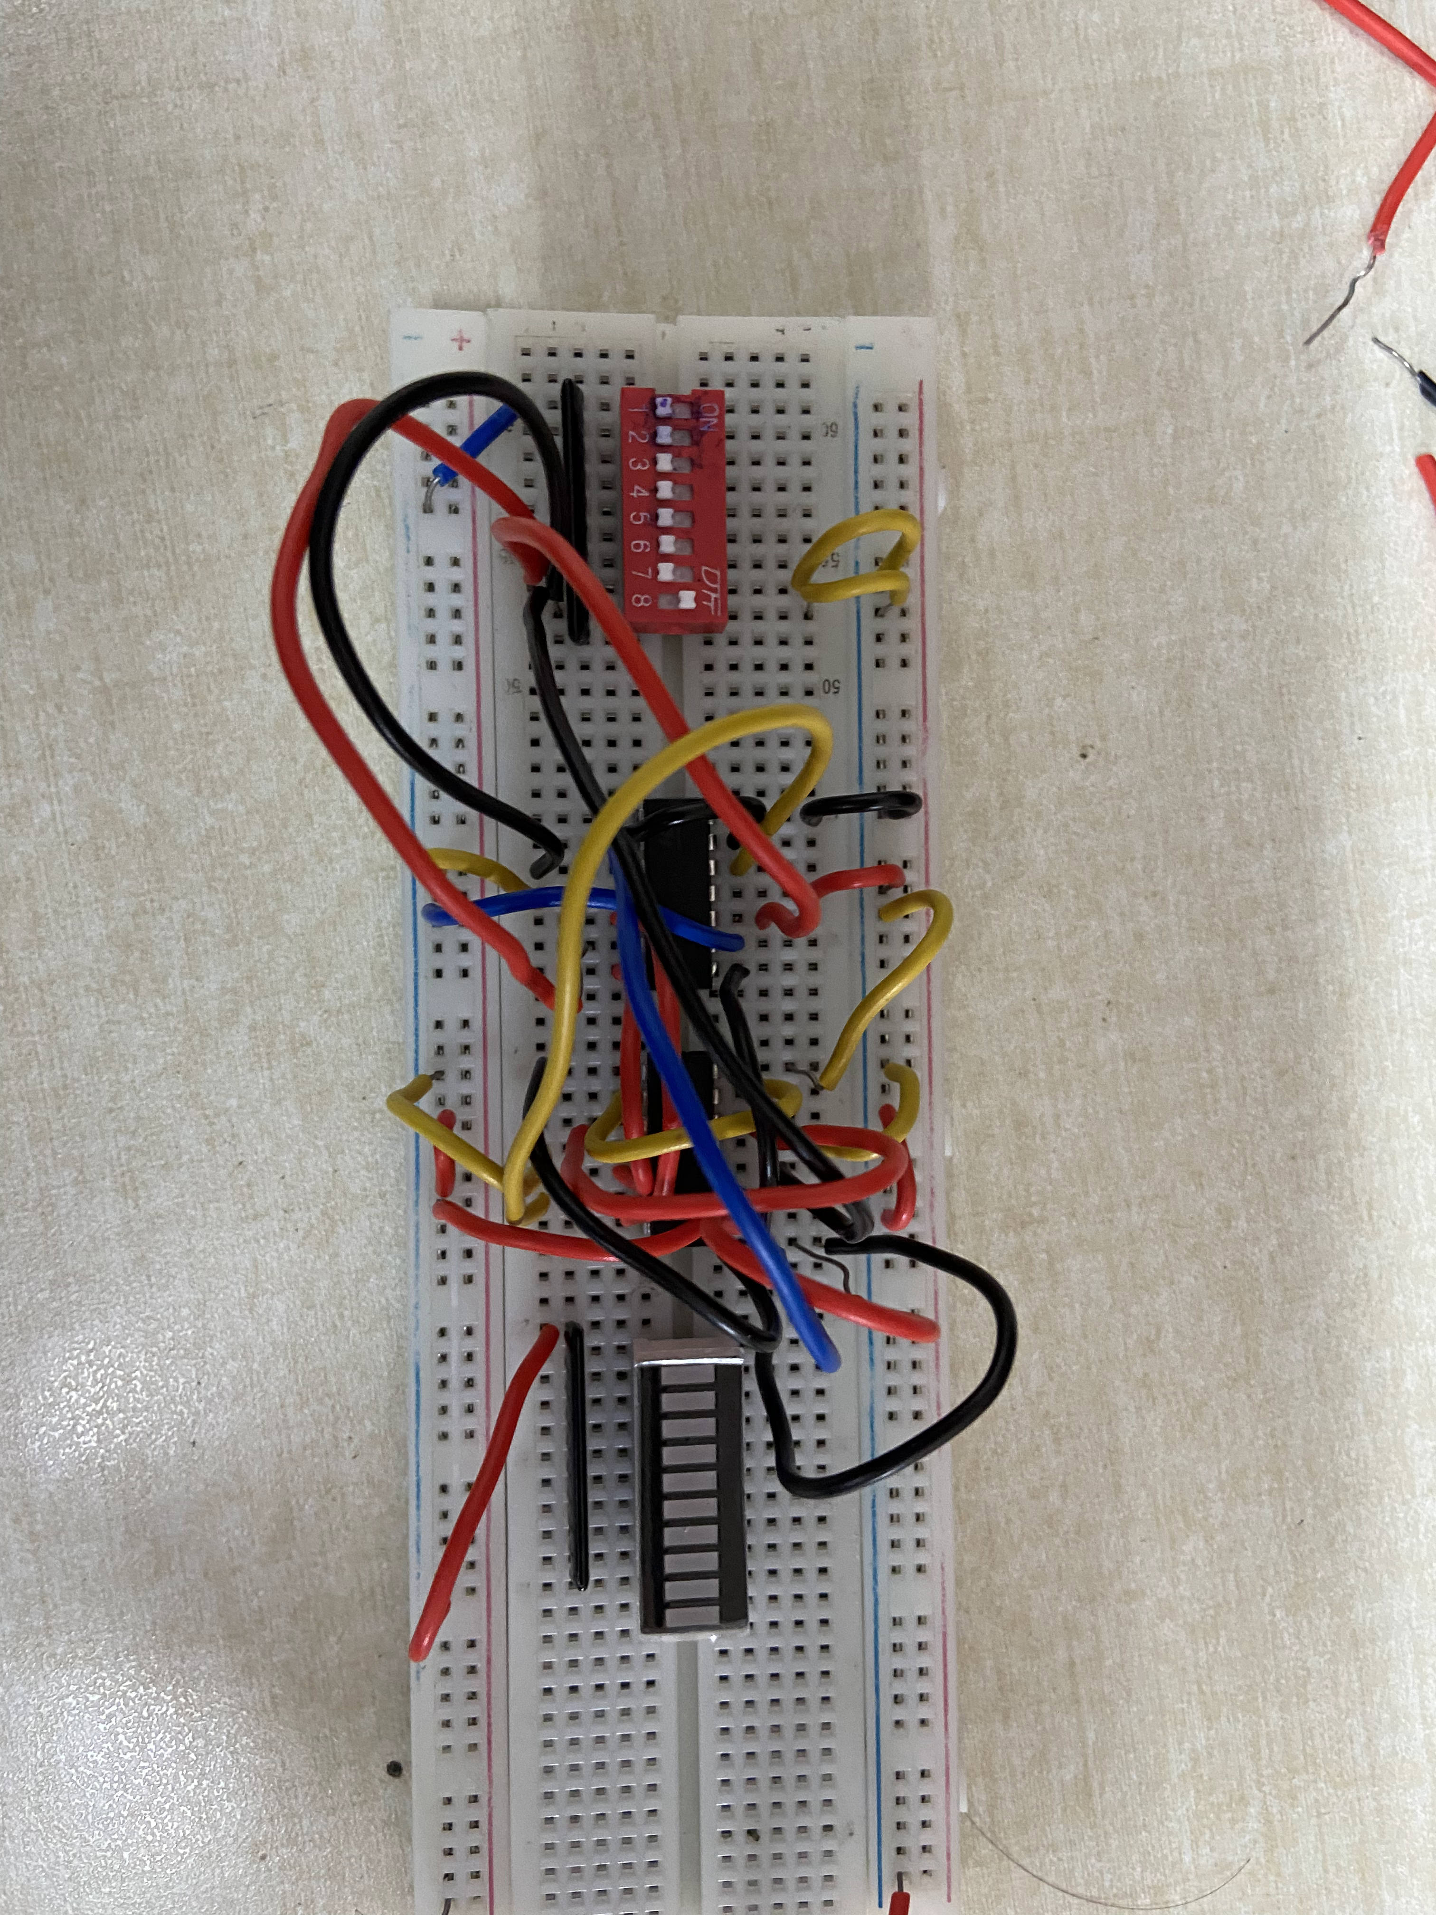

- AND GATE
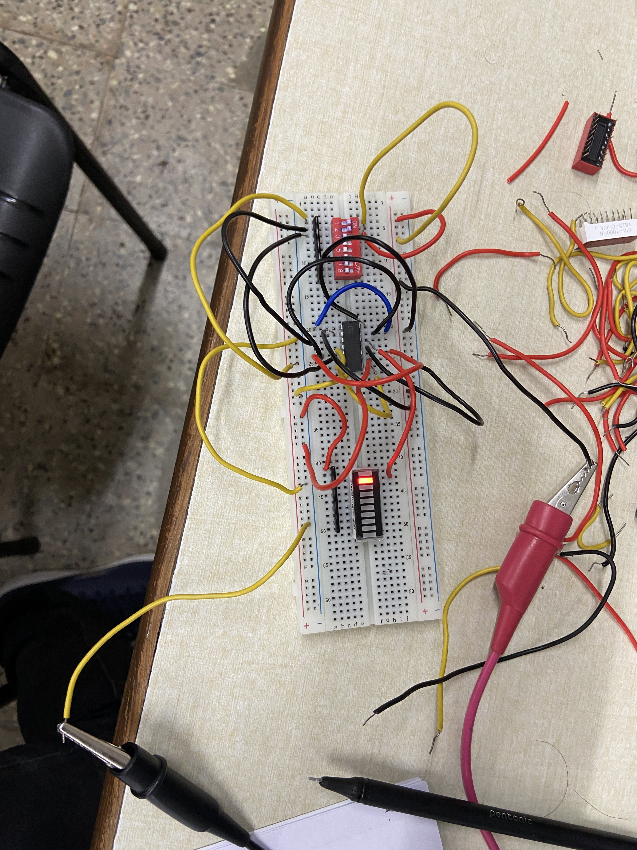
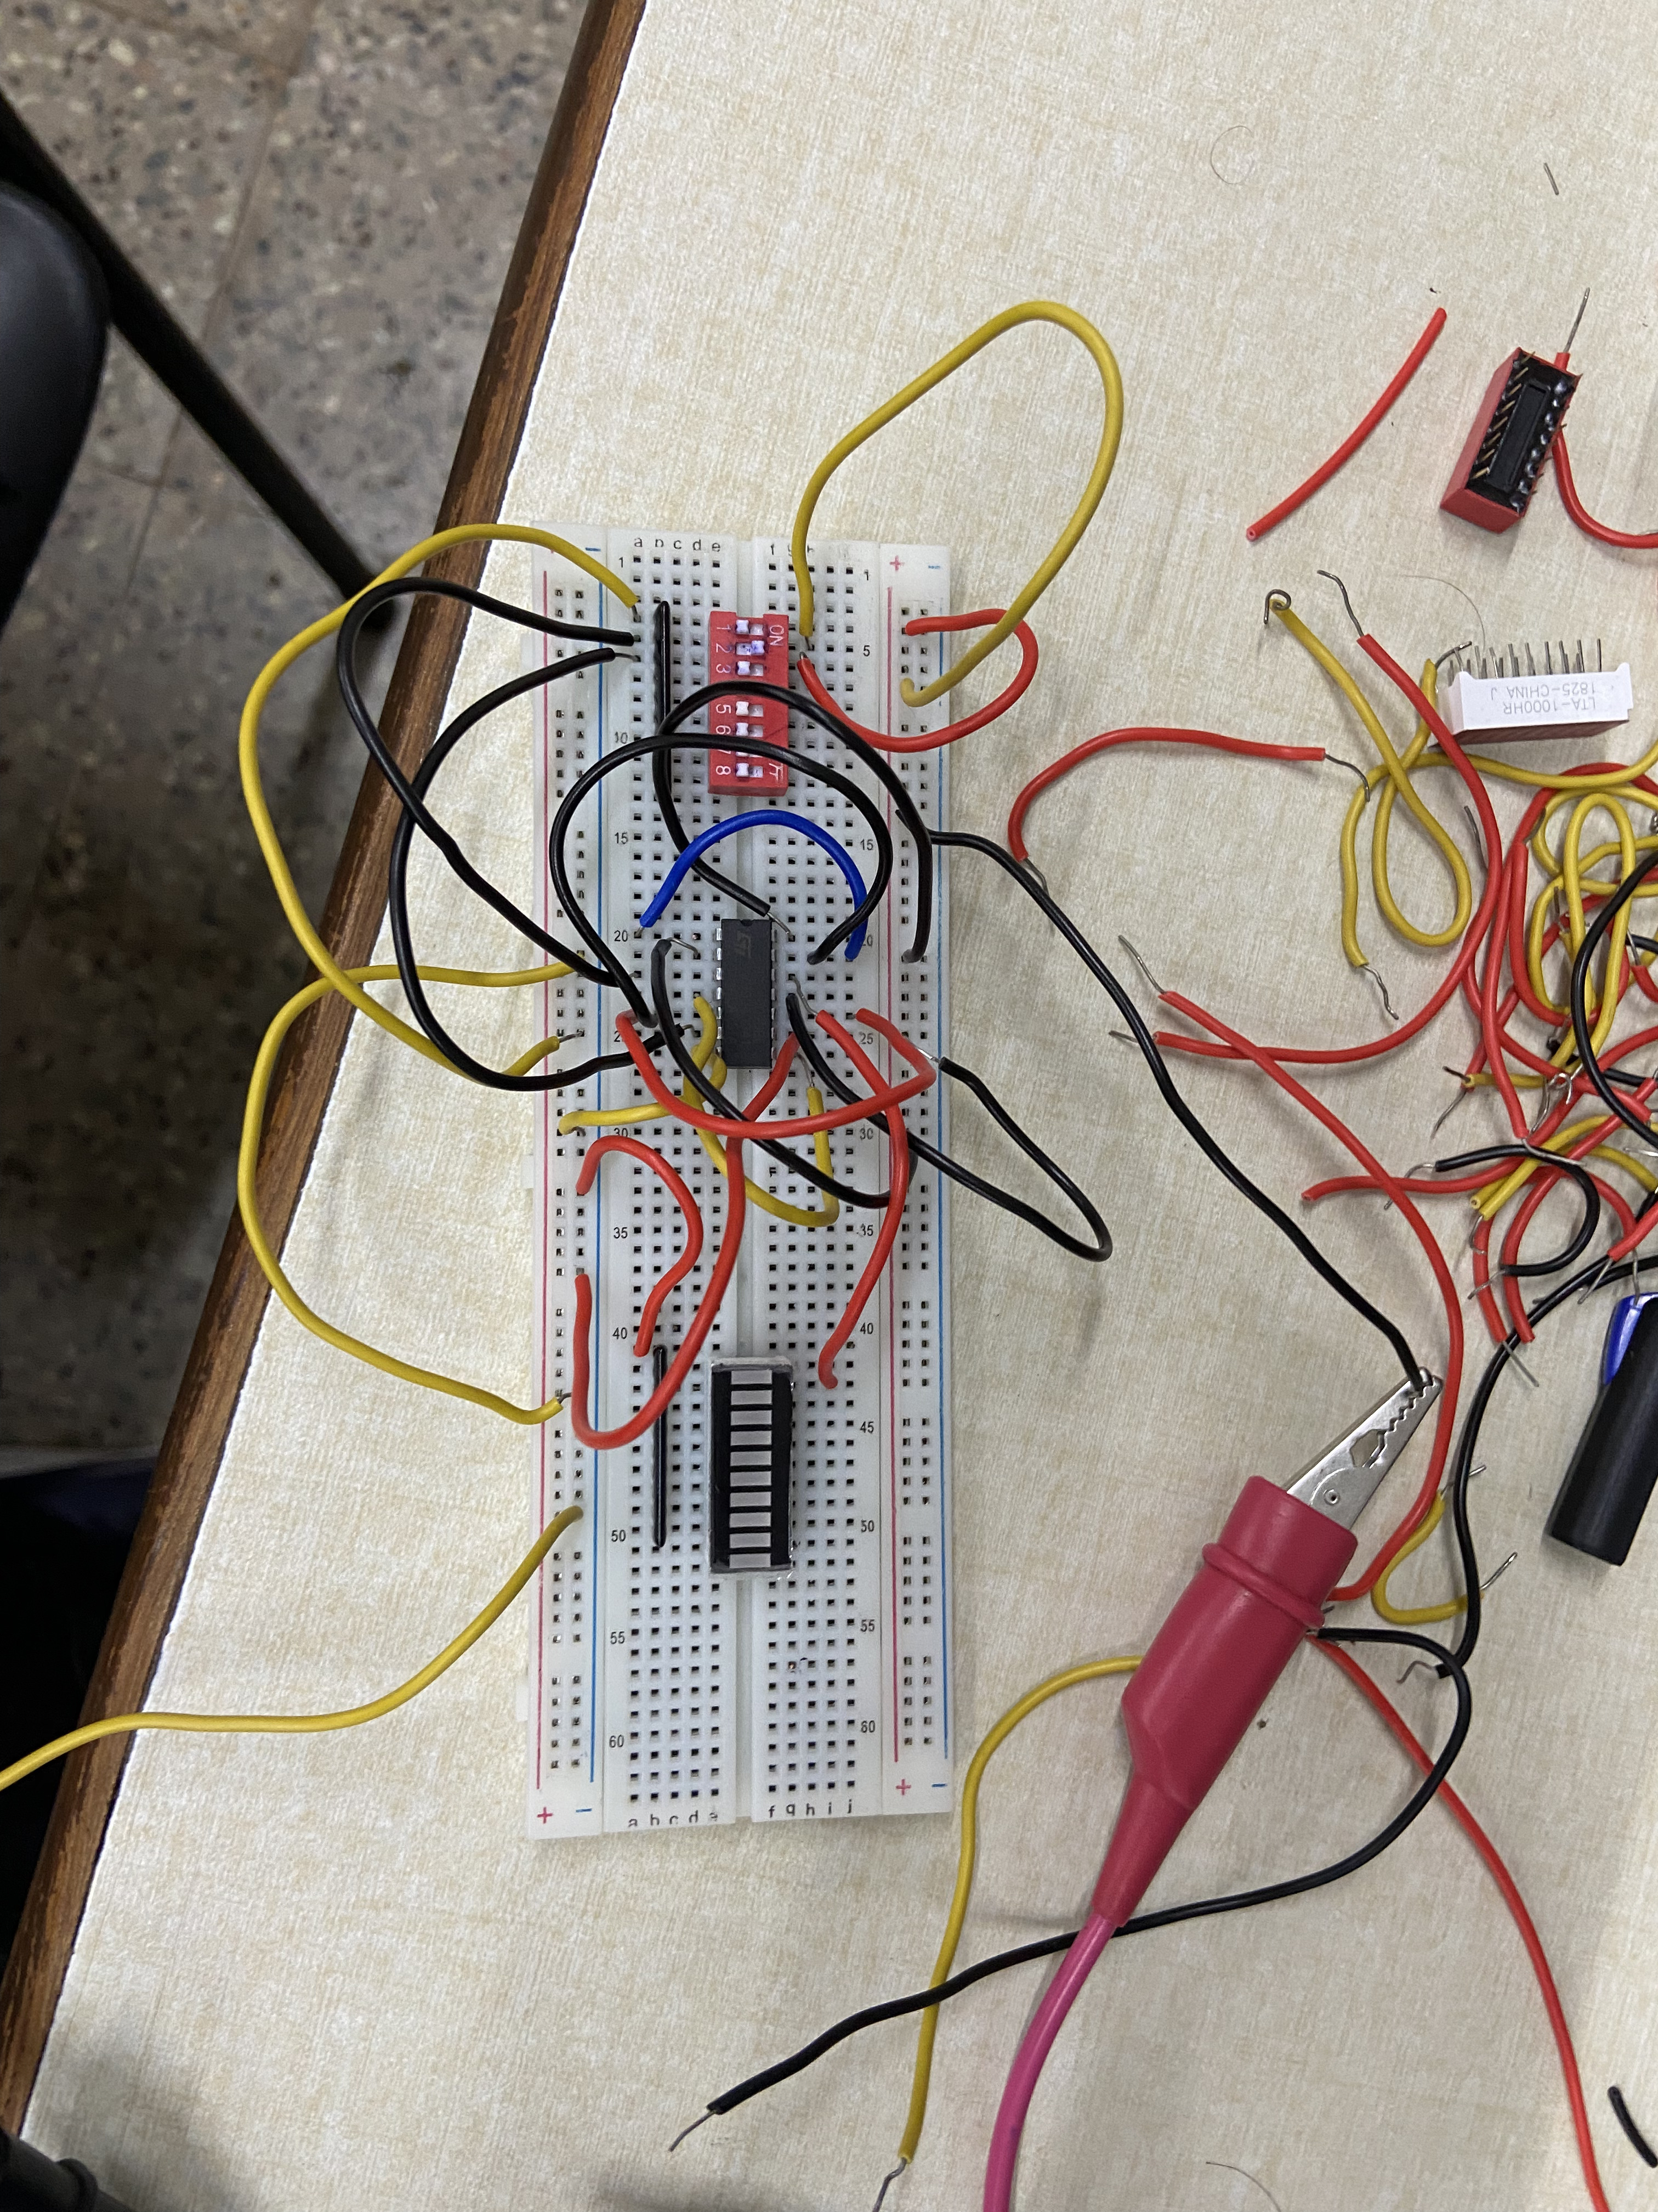

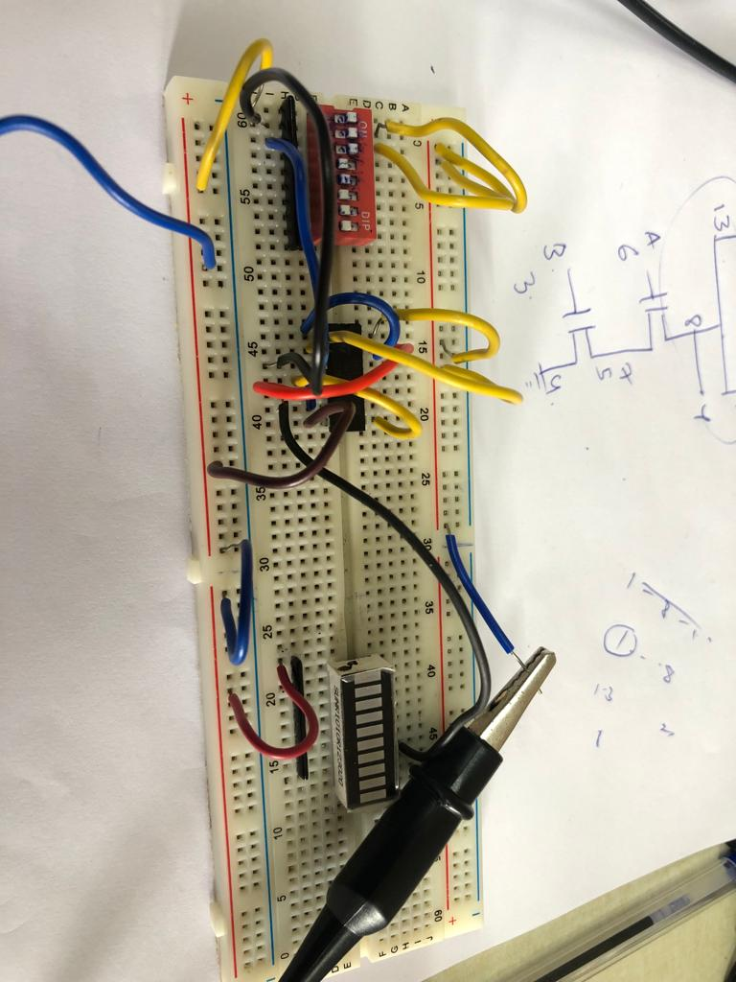
- NOR GATE

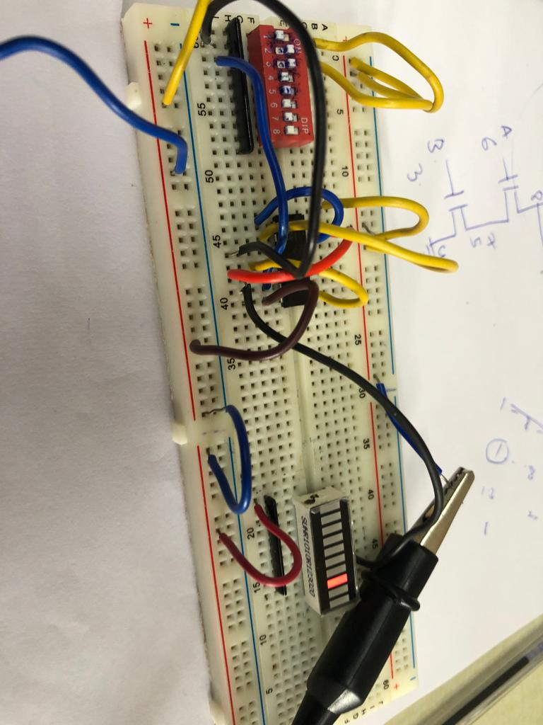
- OR GATE

Results and Discussions:

We have implemented the AND and XOR gates using the CMOS logic gates using HCF 4007’s, and have solved the problems 1 & 2 and also implemented all the other logic gates – NOR, OR, NAND, XNOR using CMOS logic gates.

Conclusion:

Logic gates for the given problems are XOR and AND respectively and we have implemented them and all other gates using the CMOS logic gates.

